Northeast TN Healthcare Workforce Philanthropy Research
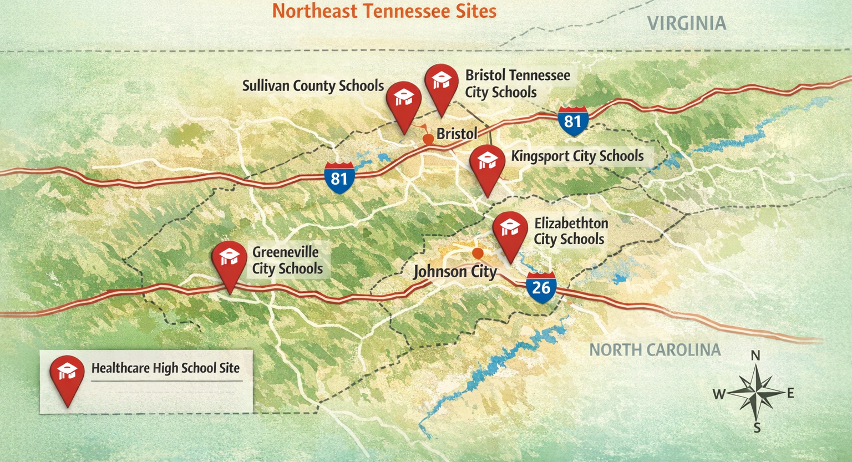

Northeast TN — Programmatic Philanthropic Investments Supporting Healthcare Workforce Development (Past 5 Years)
 | Philanthropy (Funder) | Title of Investment / Grant | Purpose (Workforce Development) | Amount | Year (Announced) | Recipient (Organization / Institute)
 | Tennessee Department of Labor and Workforce Development | Rural Healthcare Initiatives Program | Supports training, certifications, apprenticeships, and barrier-reduction services to expand the rural healthcare workforce across Tennessee; Northeast State Community College is among funded entities serving Northeast Tennessee counties. | $10.7M | 2025 | 38 grantees statewide, including Northeast State Community College serving Carter, Greene, Hancock, Hawkins, Johnson, Sullivan, Unicoi, and Washington counties
 | Tennessee Higher Education Commission | Rural Health Care Pathways Expansion Grant | Expands education and career pathways in high-demand healthcare, behavioral health, and dental fields for rural students; supports earlier exposure, stronger transitions into postsecondary training, and career advancement in rural communities. | $884,404 | 2025 | Northeast State Community College
 | Tennessee Higher Education Commission | Rural Health Care Pathways Expansion Grant | Supports expansion of rural healthcare education and career pathways, including stronger links from secondary education into postsecondary credentials and employment in high-demand health professions. | $1.9M | 2025 | Walters State Community College
 | Tennessee Hospital Association | Healthcare Collaborative Grants | Funds hospital and academic partnerships to expand clinical placements, strengthen preceptor and faculty training, and improve student access to healthcare education across multiple high-need occupations. | Up to $50K | 2024 | 15 hospital, health system, and academic institution partnerships statewide
 | Tennessee Higher Education Commission | Rural Health Care Pathways Expansion Grant | Builds and scales rural healthcare career pathways through secondary-to-postsecondary alignment, work-based learning, and program expansion in high-demand health professions. | $2.0M | 2025 | TCAT Morristown

National Private Foundations
National Private Foundation | Approx. Annual Giving | Summary of Recent Healthcare Workforce / Career Pathway Grants | Geographic Focus of Large Grants
Robert Wood Johnson Foundation (RWJF) | ~$293M annually | Funds multi-year initiatives to strengthen and diversify the healthcare workforce as part of its “Transforming Health and Healthcare” strategy. Recent grants support training pipelines for community health workers, nursing and primary care workforce diversity, leadership development, and systems change linking education, workforce, and equity outcomes. Typical awards range from $500K–$5M over 3–5 years. | Nationwide; notable investments in CA, TX, NJ, NY, IL, NC, and multi-state collaboratives
The Kresge Foundation | ~$150–160M annually | Supports healthcare workforce development through its Health and Education programs, including grants for community-based healthcare training, workforce pipelines in urban systems, and integration of health careers into postsecondary pathways. Investments often emphasize equity-focused systems of care and career access. | Major metro areas nationwide, with concentrations in Detroit, Memphis, New Orleans, Fresno, and other U.S. cities [tgci.com], [communityd...rants.info], [philanthro...digest.org]
The California Endowment | ~$150M annually | Invests in health workforce pipelines, including community health worker (CHW) training, allied health pathways, and education-to-employment models supporting underserved communities. Grants frequently link workforce development with health equity and system reform. | Primarily California (statewide), with scalable models referenced nationally
W.K. Kellogg Foundation | ~$340M annually | Supports workforce and career pathway development connected to health equity, early childhood systems, and community health infrastructure, including training for health and human services professionals and cross-sector workforce strategies. | Nationwide, with emphasis on MI, MS, NM, and national intermediaries
Bill & Melinda Gates Foundation (U.S. Program) | ~$8B total giving (portion U.S.) | Through its U.S. Education & Opportunity portfolio, funds postsecondary career pathways, accelerated credential programs, and workforce-aligned education, including pathways that feed into healthcare and allied health occupations. While not exclusively healthcare-focused, several grants support health-related workforce pipelines. | Nationwide; large grants in TX, CA, WA, NY, and multi-state initiatives
Arnold Ventures (formerly Laura and John Arnold Foundation) | ~$160–170M annually (501(c)(3) giving) | Makes targeted investments in evidence-based workforce development, including healthcare and allied health training programs (e.g., nursing, LPN, radiologic tech) paired with wraparound supports. Recent grants include state-level healthcare workforce initiatives tied to proven models. | Nationwide; recent large grants in Colorado, with replication models across states
John A. Hartford Foundation | ~$70–80M annually | Focuses on geriatrics and aging, funding training, education, and workforce capacity-building for healthcare professionals serving older adults, including nursing, emergency medicine, and home-based care. Grants often support national professional associations and academic health centers. | Nationwide; grants to institutions in NY, MA, NC, CA, and national medical associations

Northeast TN State and Local Private Foundations
State and Local Private Foundation | Approx. Annual Giving | Summary of Recent Healthcare Workforce / Career Pathway Grants | Geographic Focus of Large Grants
Tennessee Health Foundation | ~$3.8M annually | Supports programs for Tennesseans with special emphasis on addressing healthcare workforce needs, health disparities, at-risk populations, patient safety, and quality. Public materials indicate healthcare workforce is an explicit priority, though recent named awards are not broadly listed in open sources. | Tennessee statewide, with roots in Chattanooga and broader coverage across TN, GA, and VA
Tennessee Nurses Foundation | ~$152K annual revenue | Advances nursing education, leadership, mentoring, research, and scholarships statewide. Recent programs include student scholarships, leadership nursing grants, and support for professional development that strengthen Tennessee’s nursing pipeline. | Tennessee statewide

Northeast TN Corporate Foundations
Corporate Foundation | Approx. size (Total assets) | Approx. grants/year (Charitable disbursements) | Summary of funded activities
HCA Healthcare Foundation | ~$192.7M assets | ~$21.7M annually | Nashville-based corporate foundation supporting health and wellbeing in Middle Tennessee and broader HCA communities. Public materials show investments in health equity, primary care, education, and workforce-relevant community initiatives; HCA also reports broader enterprise investments in nursing education, graduate medical education, and leadership training.
Ballad Health Foundation | ~$65.0M assets | ~$5.5M grants in FY2025 | Johnson City-based health system foundation supporting education and workforce-related needs in the Appalachian Highlands. Public evidence includes nursing scholarships, tuition support for RN/LPN/radiology/respiratory pathways, and Ballad Health’s major investment with ETSU to expand the nursing pipeline and nurse educator capacity.
BlueCross BlueShield of Tennessee Community Trust | Not available | Not available | Tennessee-based corporate philanthropy focused on community health and wellbeing. Public materials show support for health improvement, healthy active lifestyles, and community health initiatives; open sources reviewed did not clearly identify recent named healthcare workforce pathway grants, so relevance is strongest where community health investments intersect with provider capacity and health careers exposure.
Dollar General Literacy Foundation | ~$69.8M assets | ~$12.1M grants in 2025 | Goodlettsville-based corporate foundation funding literacy and education in Tennessee and nationwide. While not healthcare-specific, adult and family literacy investments can support healthcare career entry by improving GED completion, English proficiency, and foundational skills needed for nursing and allied health training in local communities.
Nissan Foundation | National corporate foundation; assets not confirmed in open source reviewed | Annual grants vary; not healthcare-specific | Corporate foundation with strong Tennessee presence through Smyrna operations and long-standing support for education and community programs. Public evidence reviewed did not show direct recent healthcare workforce grants, so this entry is best understood as a Tennessee-based corporate philanthropy with potential relevance to broader career pathway and education initiatives rather than direct health workforce funding.

Northeast TN Community Foundations

Community Foundation | Approximate Annual Grantmaking | Evidence of Healthcare Workforce Development Grantmaking
East Tennessee Foundation | ~$9.6M annually | Major regional community foundation serving 25 counties in East Tennessee. Public sources show competitive grantmaking and scholarships across education, human services, and health-related needs; direct named healthcare workforce grants are limited in open sources, but the foundation is a plausible partner for rural health career pathways and medically related service capacity in Northeast Tennessee.
Community Foundation of Greater Chattanooga | ~$25.9M annually | Hamilton County community foundation with documented grantmaking for access to affordable healthcare, workforce development, scholarships, and education. Public descriptions indicate support for workforce development and health-related community needs, though open sources do not clearly isolate named recent healthcare workforce pathway grants.
Community Foundation of Middle Tennessee | ~$47.2M annually | Large regional community foundation serving 28+ counties in Middle Tennessee. Recent grantmaking includes health, positive mental health and quality of life, education, and employment/training categories; these investments can support healthcare career pathways indirectly, although public sources reviewed do not clearly list named healthcare workforce grants.

Northeast TN Nonprofits Making Workforce Development Grants
Nonprofit |  |  | Approximate Annual Grantmaking |  |  |  | Workforce Development Activities
Tennessee Center for Health Workforce Development |  |  | Incentive awards vary by program |  |  |  | Nonprofit division of the Tennessee Hospital Association that administers statewide healthcare workforce incentive programs for physicians, nurses, dentists, behavioral health, and allied health workers. Public materials cite practice-site recruitment and retention incentives, residency incentives, dental loan repayment, nursing pathway efforts, allied health partnerships, and student pipeline activities serving all 95 counties.
Rural Health Association of Tennessee / TN AHEC |  |  | Participation awards of $500 per year for AHEC Scholars |  |  |  | Supports the Tennessee Area Health Education Centers scholars program and related training that prepares a culturally competent healthcare workforce for rural and underserved communities. Public materials show scholar stipends, rural and underserved training, and East, West, and Central Tennessee program centers coordinated with nonprofit health partners.
Tennessee Independent Colleges and Universities Association |  |  | $5,000 annually for up to 2 years per student |  |  |  | Administers the Hospital Alliance of Tennessee Nursing Scholarship for BSN and RN-to-BSN students at member institutions. The scholarship is designed to strengthen the pipeline into Tennessee nonprofit hospitals by supporting nursing students who may pursue service in nonprofit hospital settings after graduation and licensure.
Hospital Alliance of Tennessee |  | Scholarship funding varies by cycle |  |  |  | Nonprofit hospital membership organization that sponsors the HAT Nursing Scholarship program to support outstanding nursing students preparing to work in Tennessee nonprofit hospitals. The program directly ties scholarship support to workforce pipeline needs in hospital-based nursing careers.
Wings Cancer Foundation | Program-specific giving; not publicly summarized in one source reviewed |  |  |  | Memphis-area nonprofit that supports oncology-related education and training alongside patient assistance and research. Public descriptions indicate funding for the education and training of future oncologists and healthcare providers, making it a targeted though specialty-specific contributor to healthcare workforce development.
Mountain People’s Health Councils |  |  |  | Received state rural workforce grant support; own annual giving not summarized |  |  |  | Scott County nonprofit health organization that is a documented recipient in Tennessee’s Rural Healthcare Initiatives program. Its participation reflects nonprofit-led healthcare workforce development through training expansion and support services in rural Appalachian Tennessee.

